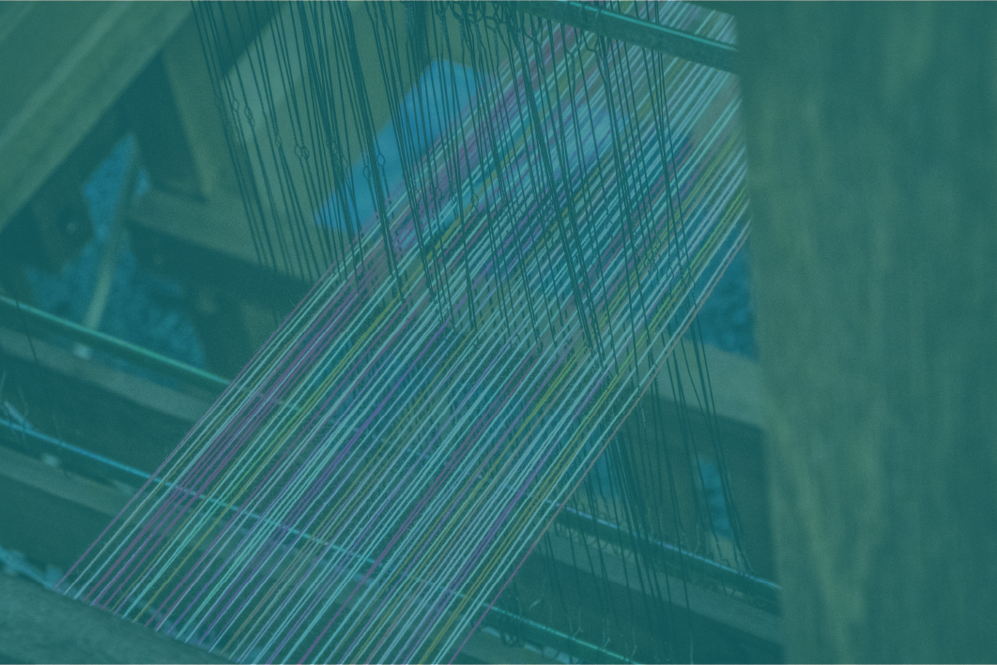


Stripe Design Workbook
Stripes I: Layout

Brainstorm Layouts
Sketch your stripe designs below. Create two designs with warp stripes, two designs with weft stripes, and two designs with both warp and weft stripes.
Important: Don’t try to do a detailed design, and don’t try to evaluate or edit the design as you’re creating it. The idea is to generate ideas for stripe design quickly, so you can select an idea to develop more fully later. Spend at most five minutes on each design.

Brainstorm Designs: Warp stripes
Loosely sketch two (or more!) project designs that use only warp stripes. Don’t spend more than a few minutes per sketch.

Brainstorm designs: Weft stripes
Loosely sketch two (or more!) project designs that use only weft stripes. Don’t spend more than a few minutes per sketch.

Brainstorm designs: Warp AND weft stripes
Loosely sketch two (or more!) project designs that use warp and weft stripes. Don’t spend more than a few minutes per sketch.

Evaluate layouts
What layouts do you typically use?
Look at three of your sketches from the previous exercise, and answer these questions for each one.

Sketch #1
(Add a copy of the sketch here)

What proportions are you using between stripes? How does that affect perception of your colors?

Is the design symmetrical or asymmetrical? If asymmetrical, did you choose to balance it? How did you balance it, if you did?

What rhythm and motion did you use?

Sketch #2
(Add a copy of the sketch here)

What proportions are you using between stripes? How does that affect perception of your colors?

Is the design symmetrical or asymmetrical? If asymmetrical, did you choose to balance it? How did you balance it, if you did?

What rhythm and motion did you use?

Sketch #3
(Add a copy of the sketch here)

What proportions are you using between stripes? How does that affect perception of your colors?

Is the design symmetrical or asymmetrical? If asymmetrical, did you choose to balance it? How did you balance it, if you did?

What rhythm and motion did you use?

What layouts do you use most often?
Look back on your entries on the previous pages. What characteristics do your brainstormed layouts have in common? What leads you to use them?

What layouts do you like?
Find three or four finished projects that you like. They can be your own projects or others’ designs. (They don’t have to be handwoven, either!)
Put a copy of each image below.

What do these projects have in common? What proportions do they use? What kinds of balance, rhythm, and motion do they use?

Are there layouts that you like but don’t use? What would you like to play with in future projects?

Experiment with Layouts
Choose a layout that you want to experiment with. Here are some questions to ask yourself:
- What proportions do I want to use between stripes? Equal size, lopsided proportions, or a balance between the two?
- Do I want to play with symmetry, or asymmetry? Will the design be balanced?
- What rhythm will I use (regular, rhythmic, irregular)?
- Do I want to create vertical or horizontal motion?
Sketch several ideas for layout on the next two pages. We’ve included space for three, but you can do as many as you want!

Design #1

Design #2

Design #3

Finish your design
Choose one of your brainstormed designs and develop it further. Play with both colors and layout. Explore how altering the colors changes rhythm, motion, balance, etc. in the design.

Put your finished design below.

